



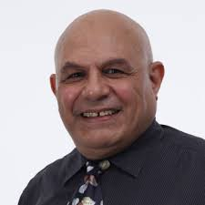

*Medical internships are of great significance for medical students to cultivate clinical thinking and sharpen clinical skills and are an essential part of medical education. A high-quality internship is a critical transition from theoretical learning to clinical practice (*Oudong Xia et al 201)

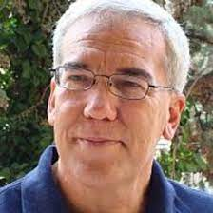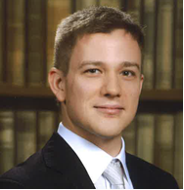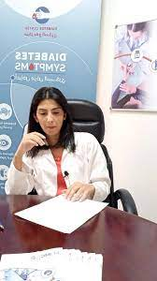

***Prof. Dr. Mosad Zineldin, LNU***

***Head of the EU/Erasmus+ Project***

<https://www.icare2021zin.com/>

**Medical Education and Internship Systems (MEIS)**

**In different EU and Arab Countries (e.g. Egypt & Lebanon)**

**A blended workshop organized by Linnaeus University (LNU) - Sweden**

**Hosted by Badr University- Cairo (BUC)**

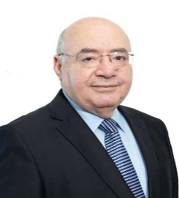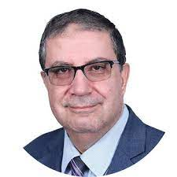

**13-15 December 2021 (A DRAFT)**

|  |  |  |  |  |  |
| --- | --- | --- | --- | --- | --- |
| **Date** | **Time** | **Presenter/speaker** | **Topic** | **University** | **Country** |
| **Monday**  **13/12** | 0.9.00 – 0.9.20 | ALL | Registration | Badr University in Cairo (BUC) | Egypt  (EG) |
| Onsite/online | 09.20- 09.30 | Prof. Moustaf Kamal  President of BUC | Welcome speech |  |  |
| 0.9. 30 – 09. 40 | Prof. Mosad Zineldin  Rep. Grant holder University | Welcome and Project breif | Linnaeus University  (LNU) | Sweden  (SE) |
| 0.9.40-09.50 | Prof. Ahmed Makhlouf  Dean of Faculty of Medicine | Welcome and practical issues | BUC | Egypt |
| Online | 10.00 -11.15 | Prof. Carlo Pesce  Prof. Leda Masi | Generla Lay out of Medical program | Faculty of Medicine-Genoa University | Italy |
| Onsite/online | 11.15- 12.15 | Dr. Vid Velikić | Internship at Medical University of Vienna | IDM/Medical University in Vienna | Austria |
|  | 12.15- 12.30 | Coffee Break |  |  |  |
| Online | 12.30 – 13.30 | Dr. Alain Chalhoub | Structure/system of medical and nurse senior student internship/ | Notre Dame University | Lebanon |
|  | 12.30 -14.00 | University Tour & Lunch |  |  |  |
| Onsite/online | 14.00 – 14.45 | Dr. Kristjan Martin Kasterpalu  North Estonai Region.Hospital | Medical Study& Practice systems in Estonia | TalTech University | Estonia |
| 14.45 – 15.45 | Prof. Mohamed Houri | Medical Internship at BAU | Beirut Arab University | Lebanon |
| Moderators | 15.45- 17.00 | Prof. Mosad Z&Pro. Ahmed M. | Brain Storming Round Table | LNU & BUC | SE&EG |
|  | 19.00 – 21.00 | LNU/BUC. | Dinner and Socialization | ALL Partners |  |

|  |  |  |  |  |  |
| --- | --- | --- | --- | --- | --- |
| **Date** | **Time** | **Presenter/speaker** | **Topic** | **University** | **Country** |
| **Tusday 14/12** | 0.9.15 – 10.00 | Prof. Ahmed Makhlouf  Dean of Faculty of Medicine | Medical system & Internship in Egypt with focus on  BUC & Assiut University | BUC | Egypt |
| Online | 10.00 – 11.15 | Prof. Mohamed Maghnie  Chairman of Pediatrics  Prof. Carlo Pesce | Clinical Training and optional formation opportunities | Faculty of Medicine at Genoa University | Italy |
| Onsite/online | 11.15- 12.00 | Dr. Samah Al Bitar  Director of MUBS medical center | Structure and functions of the MUBC medical center | Modern University of Business & Science | Lebanon |
|  | 12.00 – 12.20 | Coffee break |  |  |  |
| Onsite/online | 12.20- 13.30 | Dr. Vid Velikić | Experience and reflection of Internship & practical period | IDM/Medical University in Vienna | Austria |
|  | 13.30- 14.30 | Lunch time |  |  |  |
| Onsite/online | 14.30 – 15.15 | Dr. Ahmed Soliman  ICC | Reflection and Experiences of house office period at Alexandria University | Alexandria International Cardiology Center (ICC) | Egypt |
| Online | 15.15 – 16.30 | Dr. Jonas Zineldin  Varnamo hospital, Sweden  Dr. Sabina Siranlou, Varnamo Residency in family Medicine r -Sweden | Experiences of Practical training, General practice (AT) & Special practice (ST) in Sweden | Reflection based on the study at Karolinska Institute-Medical University | Sweden |
| Onsite/onlin | 16.30 – 18.00 | Prof. Mosad Z&Pro. Ahmed M. and other Italien colleagues | Round Table discussion, finlaization & the draft of the roadmap | ALL participants | ALL |

|  |  |  |  |  |  |
| --- | --- | --- | --- | --- | --- |
| **Date** | **Time** | **Presenter/speaker** | **Topic** | **University** | **Country** |
| **Wednsday 15/12** | 10.00. – 13.00 | Prof. Mosad Z&Pro. Ahmed M. and other Italien colleagues | Round Table discussion, finlaization & the draft of the roadmap | ALL participants | ALL |
|  | 13.00 – 14.00 | Lunch |  |  |  |
| Onsite/online | 14.00- 17.00 | Professor Mosad Zineldin | Management and coordination meeting  Finalization of wp1 survey | ALL participants | ALL |

<https://lnu.se/en/research/searchresearch/research-projects/project-icu--knowledge-triangle-innovation-reinforcing-of-education-research-e.health--medical-links/>

<https://www.icare2021zin.com/>